Current Activities & Acquisitions

Electromatic Typewriter

Our Electromatic typewriter has arrived. On inspection we believe this model may have been built between 1933, when Electromatic was acquired by IBM and 1935, when IBM's redesigned version was released. Investigations continue.

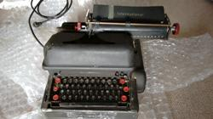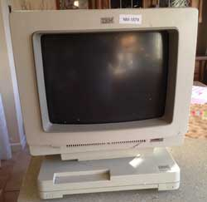

3179

We have also now obtained the 3179 colour display terminal mentioned in the previous report. Unfortunately it was damaged in transit, showing signs of being dropped from a great height. The monitor case is cracked in a number of places, but the machine appears to still be functional. This is a Model 2, which was specifically designed for connection to AS/400 and related mid-range systems.

The only positive is that we obtained a full refund from eBay for the shipping costs plus half the cost of the machine.

Other

A lesson in managing loans to other organisations. Some years ago the museum loaned a number of artefacts to an organisation in Winchester aimed at teaching children about technology. This was somewhat before my time, and the loan agreement was not followed up annually as it should have been, until we discovered it in the files last year. We requested return of our artefacts after we learned that two items had gone missing.

In spite of a comprehensive search the missing items have not been located and we must assume lost. We are always willing to lend out items but in future we will need to inspect the security measures at the display location and carry out regular checks.

